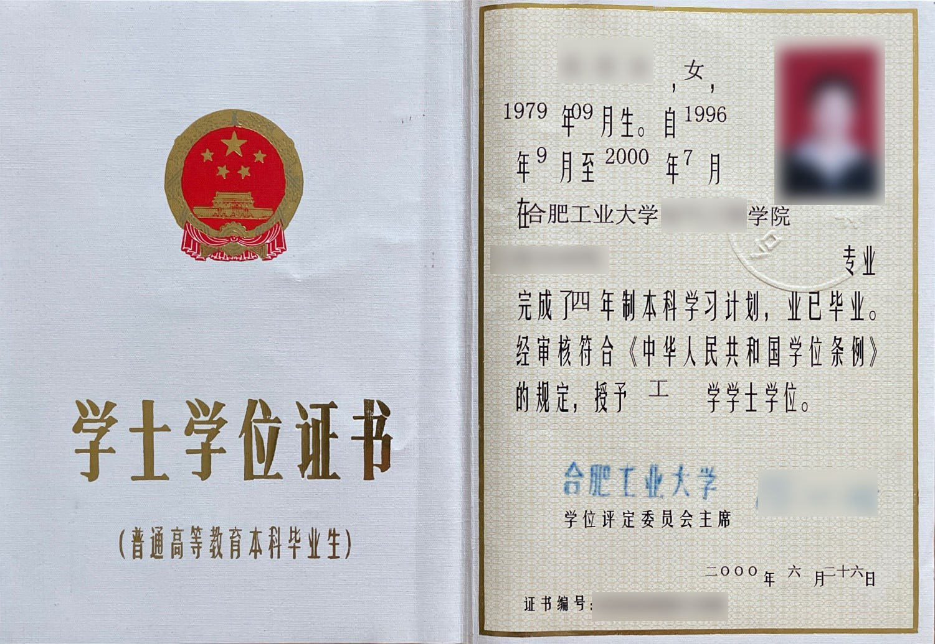

DEGREE OF BACHELOR CERTIFICATE

Let it be known that student 姓名, 性别, born in 年 月 日, having specialized in 专业 of 学院 from 年 月 to 年 月 and completed the the four/five years’ undergraduate program with qualified standing, and passed the prescribed examinations and all other requirements of “THE RULES FOR ACADEMIC DEGREES OF THE PEOPLE’S REPUBLIC OF CHINA”, is hereby granted THE DEGREE OF BACHELOR OF ENGINEERING.

证书日期
Degree Committee Chairman of Hefei University of Technology:
校长姓名
Certificate No. 证书编号

